**EMBEDDED SYSTEMS**

**PROJECT DESIGN**

**Desk Stand Up Reminder**

Member’s Name: NAVARRO, ROD GERYK C.

Course/Section: CPE160P-4/A1

Group No.: N/A

Progress Report Number: 10/13/2024

Date of Submission: 10/13/2024

CYREL O. MANLISES, PH.D.

Instructor

Part I. Discuss in detail your progress here.

For my progress in this project, I first connected all the components to the Arduino R3. These include five buttons, an ultrasonic sensor, a 16x2 LCD display, a 4-digit seven-segment display, a buzzer, and two LED lights. I made sure all the connections were done properly. While working on this, I also planned the layout of my circuit on the breadboard because I intend to create a small casing to store all the connections. The goal is to keep the important components, like the ultrasonic sensor, LCD, seven-segment display, buttons, LEDs, and buzzer, accessible from the outside of the case.

Hence, when connecting everything, I ran into a problem. Since many of the Arduino's pin slots were already used by other components, I didn’t have enough pins left to connect all five buttons. To solve this, I used a technique that allows me to connect multiple buttons to a single analog input. By using different resistors for each button, I can get different voltage readings from each one, making it possible to identify which button was pressed in the code. Apart from this issue, I made sure all the connections were correct and aligned with my planned case design.

Part II. Provide screenshots as proof of your progress.

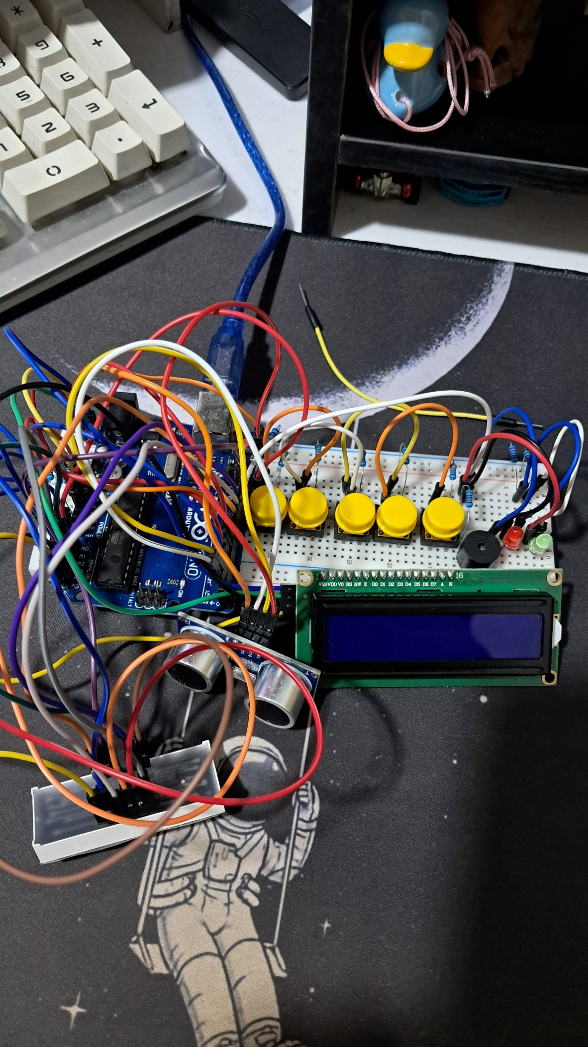

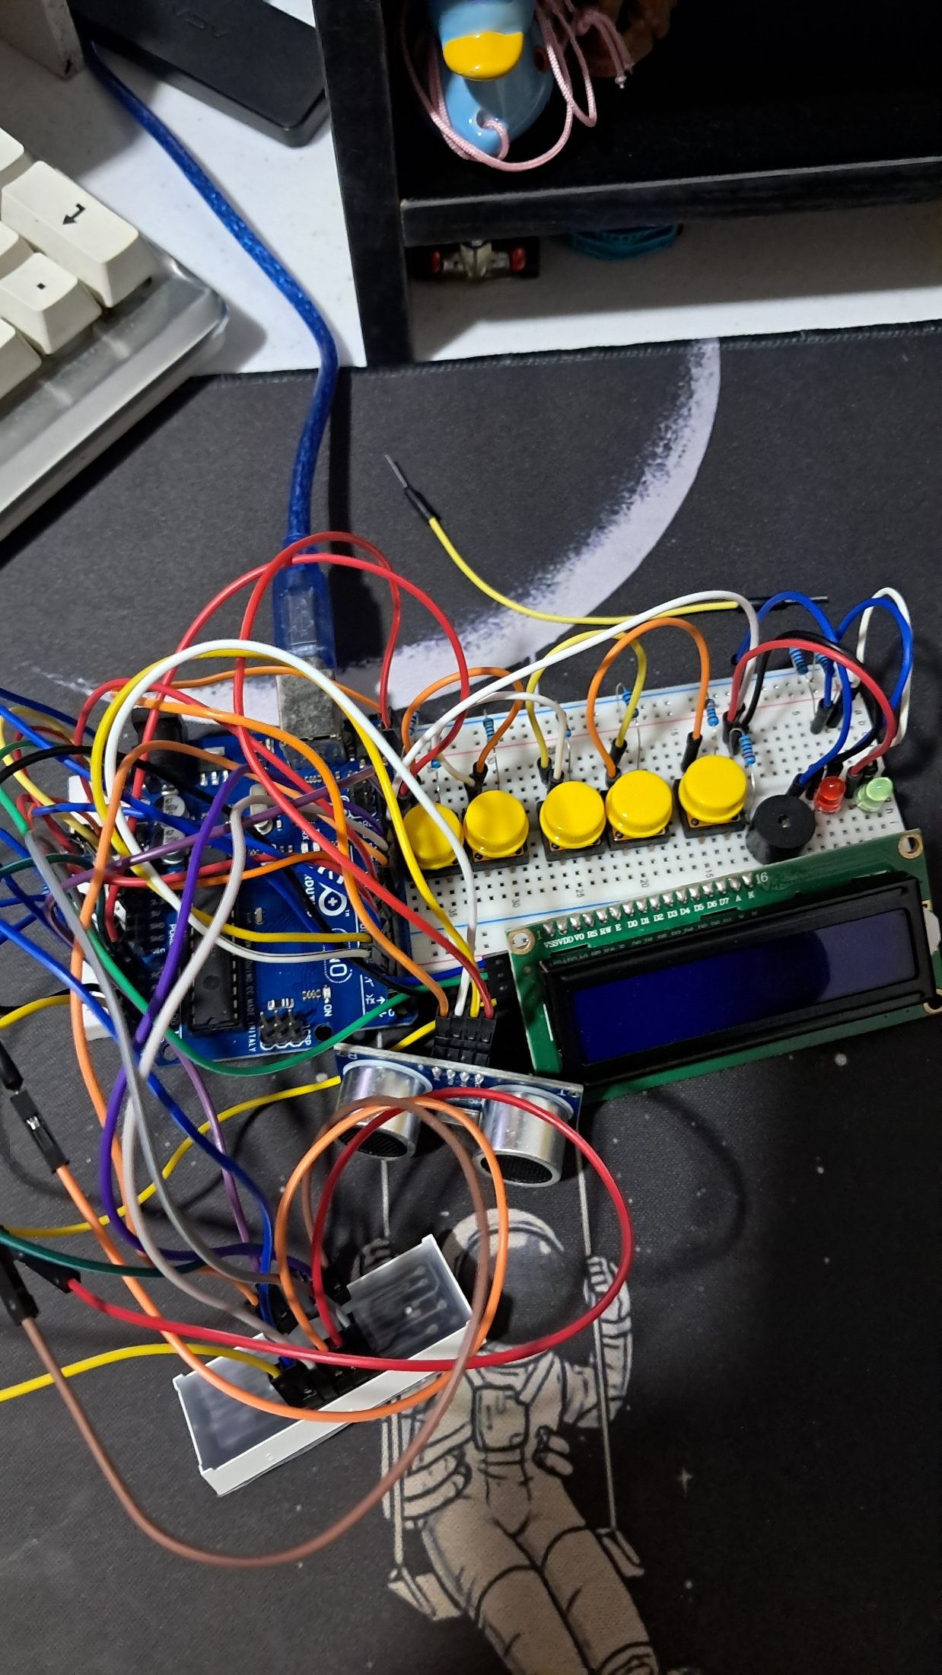

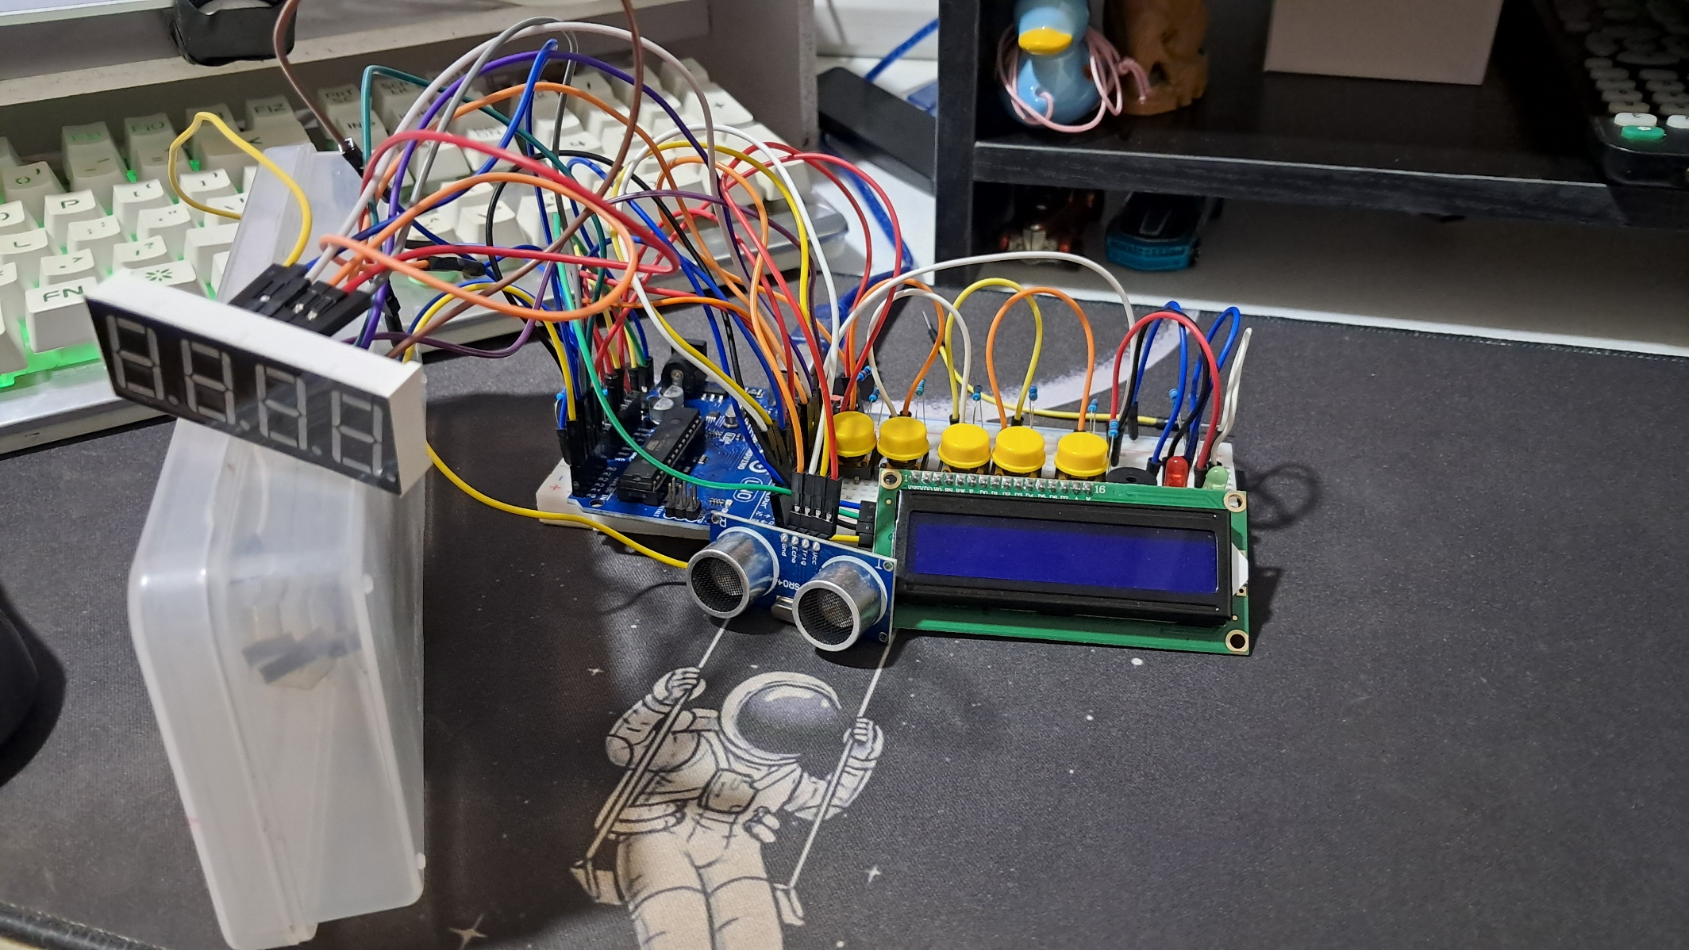

**Figure 1: The completed connections of the components.**

Part III. List down your work load

* Make sure all the components are connected correctly.
* Start working on the case design.
* Design the circuit based on the case planned.
* List the pin connections for each component.
* Fix any issues in the connections.

Part IV. Gantt chart

